

**Data Modelling and Database Design**

**Submitted By:** Client’s Name

**Roll no:** Client’s Roll #

**Submitted To:** Cleint’s Instructor’s name

**Subject:** Client’s Subject Name

**Semester/Session:** Client’s Semester or session

**Question:**

Provide SQL statements and the query output for the following

1. **Display all the customers having full names longer than 10 characters.**

**Source Code:**

SELECT CustomerID,Given As FullName

FROM customer

WHERE LENGTH(Given) > 10;

**Output:**

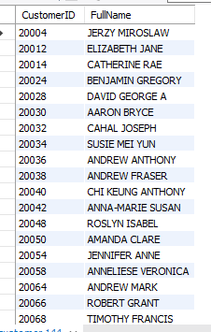

**Explanation:**

We Assumed that “Given” is full name of customer and applied the condition on that column.

1. **List all the names of the customers if their names contain the string 'ON', ignoring the case.**

**Source Code:**

SELECT Given AS Full_name

FROM customer

WHERE LOWER(Given)

LIKE '%on%';

**Output:**

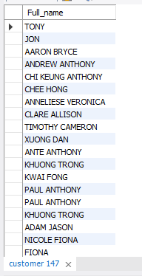

1. **Which plan has the highest number of cancelled phone numbers?**

**Source Code:**

SELECT PlanName,

COUNT(*) AS Total_Cancelled_Phone_No

FROM mobile

WHERE Cancelled IS NOT NULL

GROUP BY PlanName

ORDER BY Total_Cancelled_Phone_No DESC

LIMIT 1;

**Output:**

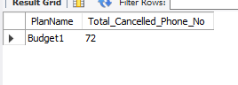

1. **How many customers have more than one active phone number?**

**Source Code:**

SELECT DISTINCT(SUM((SELECT COUNT(CustomerID) FROM mobile)))

AS Total_Customers_with_more_than_1_Active_Phones

FROM Mobile

WHERE Cancelled IS NULL

GROUP BY CustomerID

HAVING COUNT(DISTINCT PhoneNumber) > 1;

**Output:**

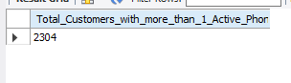

1. **Generate a report displaying the total number of customers by each state.**

**Source Code:**

SELECT State,COUNT(*) AS Total_Customers

FROM customer

GROUP BY State

ORDER BY Total_Customers DESC;

**Output:**

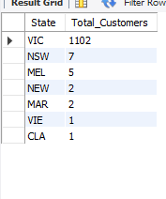

1. **Is there any staff who is also a customer? Write an SQL query to support your answer.**

**Source Code:**

SELECT Distinct s.StaffID, s.Surname

FROM STAFF s

LEFT JOIN MOBILE m ON s.StaffID = m.StaffID

RIGHT JOIN CUSTOMER c ON m.CustomerID = c.CustomerID

WHERE c.CustomerID IN(s.StaffID);

**Output:**

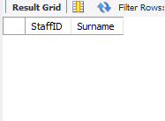

**Conclusion:**

There is no staff member who is also a customer.

1. **Display the supervisor's details and the total number of staff they supervise.**

**Source Code:**

SELECT SupervisorID,COUNT(*) AS TotalStaff

FROM STAFF

WHERE Resigned IS NULL

GROUP BY SupervisorID;

**Output:**

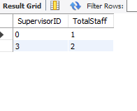

**Conclusion:**

Other supervisors who are not displayed in output data are those supervisors who’s all staff member have resigned so technically they are not supervising anyone.

1. **List all the staff who are not supervisors.**

**Source Code:**

SELECT staff1.StaffID,staff1.Given AS Full_Name

FROM staff staff1

LEFT JOIN staff staff2

ON staff1.StaffID = staff2.SupervisorID

WHERE staff2.SupervisorID IS NULL;

**Output:**

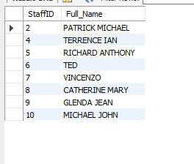

1. **Did the total number of calls increase during the COVID lockdown period (2020) compared to 2019? Substantiate your answer with an SQL query.**

**Source Code:**

SELECT YEAR(CallDate) AS 'Year', COUNT(*) AS Total_calls

FROM calls

WHERE YEAR(CallDate) IN (2019, 2020)

GROUP BY YEAR(CallDate);

**Output:**

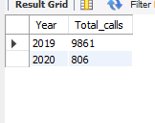

**Conclusion:**

No, total number of calls does not increase in COVID Lockdown Period (Year 2020) as compared to 2019 rather, number of calls decrease in 2020 as compared to 2019.

1. **What is the second least popular phone colour among customers?**

**Source Code:**

SELECT PhoneColour, COUNT(DISTINCT CustomerID) AS Total_Customers

FROM mobile

GROUP BY PhoneColour

ORDER BY Total_Customers ASC

LIMIT 1 OFFSET 1;

**Output:**

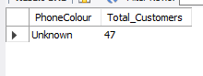

**Conclusion:**

Name of Phone’s color that is second least popular color is “Unknown” (According to table)

1. **List all the customers who are not active. A customer should be considered not active if they have no active phone number registered under their name.**

**Source Code:**

SELECT DISTINCT customer.CustomerID AS Non_Active_Customers,

customer.Given AS FullName

FROM customer

LEFT JOIN (

SELECT CustomerID, COUNT(*) as active_count

FROM mobile

WHERE Cancelled IS NULL

GROUP BY CustomerID

) mobile

ON customer.CustomerID = mobile.CustomerID

WHERE mobile.active_count IS NULL;

**Output:**

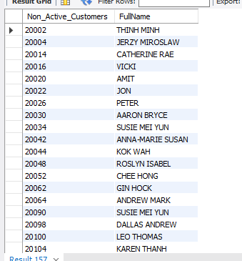

1. **What plan is most popular among customers who are born before the 1960s?**

**Source Code:**

SELECT Mobile.PlanName, COUNT(*) as Popularity

FROM Mobile

JOIN Customer ON Customer.CustomerID = Mobile.CustomerID

JOIN Plan ON Plan.PlanName = Mobile.PlanName

WHERE YEAR(Customer.DOB) < 1960

GROUP BY Plan.PlanName

ORDER BY Popularity DESC

LIMIT 1;

**Output:**

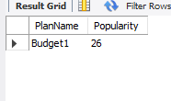

1. **Write a query to display the total income generated by the company in 2019 from call charges based on gender. Assume call duration is recorded in seconds and calls are charged per minute.**

**Source Code:**

SELECT customer.Sex,

SUM(CASE WHEN YEAR(calls.CallDate) = 2019 THEN calls.CallDuration/60 * plan.CallCharge ELSE 0 END) AS Total_Income

FROM CUSTOMER

INNER JOIN MOBILE ON customer.CustomerID = mobile.CustomerID

INNER JOIN PLAN ON mobile.PlanName = plan.PlanName

INNER JOIN Calls ON mobile.MobileID = calls.MobileID

GROUP BY customer.Sex;

**Output:**

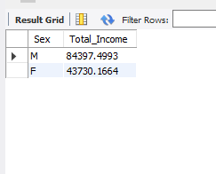

1. **Is there any mobile plan in the plan table that has never been used? Show this using**

**i. Sub-query**

**ii. Joins**

**Source Code And Output:**

**Using SubQuery:**

SELECT *

FROM plan

WHERE PlanName NOT IN (

SELECT DISTINCT PlanName

FROM mobile

);

**Output:**

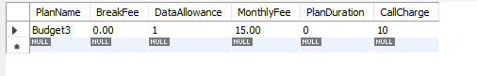

**Using Joins:**

SELECT DISTINCT plan.*

FROM plan

LEFT JOIN mobile ON plan.PlanName = mobile.PlanName

WHERE mobile.PlanName IS NULL;

**Output:**

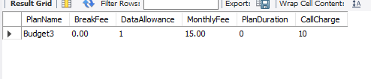

1. **Which tower(s) were used by customer 20010 to make the first call?**

**Souce Code:**

SELECT Distinct tower.towerid

FROM tower

JOIN connect ON tower.towerid = connect.towerid

JOIN calls ON calls.callsid = connect.callsid

JOIN mobile ON mobile.mobileid = calls.mobileid

JOIN customer ON customer.customerid = mobile.customerid

WHERE customer.customerid = 20010

ORDER BY calls.calldate, calls.calltime

LIMIT 1;

**Output:**

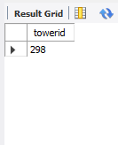

1. **Did any customer break their mobile plan before the mobile plan duration ends? Assume the plan duration is in months. Justify your answer with an SQL query by producing a list of customers who cancelled the plan before the duration expires.**

**Souce Code:**

SELECT mobile.customerid, mobile.planname, mobile.joined, mobile.cancelled, plan.planduration

FROM mobile

JOIN plan ON mobile.planname = plan.planname

WHERE mobile.cancelled < DATE_ADD(mobile.joined, INTERVAL plan.planduration MONTH);

**Output:**

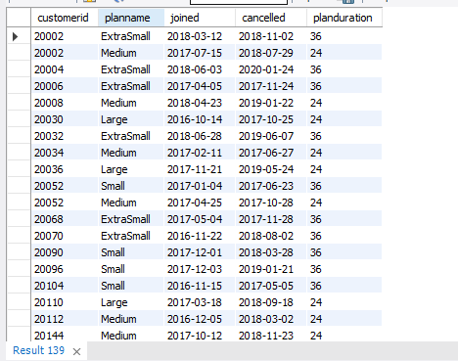

**Conclusion:**

Alot of customers have broken their mobile plan before the mobile plan duration ends

1. **Create a view showing the popularity of phone colours based on the total number of active users.**

**Use this view to show the least popular colour.**

**Source Code:**

#creating view

CREATE VIEW Popular_colour AS

SELECT phonecolour, COUNT(*) AS active_users

FROM mobile

WHERE cancelled IS NULL

GROUP BY phonecolour

ORDER BY active_users DESC;

#using View

SELECT phonecolour, active_users

FROM Popular_colour

ORDER BY active_users ASC

LIMIT 1;

**Output:**

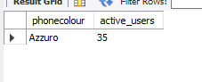

1. **Write a query to fetch the data about the first call, including the customer details, the phone number the call was made and the total number of towers used for the connection.**

**Source Code:**

SELECT customer.customerid,customer.given, mobile.PhoneNumber, calls.Calldate, count(Distinct(tower.towerid))

FROM calls

JOIN mobile ON mobile.mobileid = calls.mobileid

JOIN customer ON customer.customerid = mobile.customerid

JOIN connect ON connect.CallsID = calls.callsid

JOIN tower ON tower.towerid = connect.TowerID

WHERE calls.calldate = (SELECT MIN(calldate) FROM calls);

**Output:**

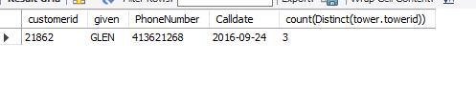

1. **Who is the youngest and oldest customer of postcode 3181, having an iPhone?**

**Source Code:**

SELECT

youngest.customerid,

youngest.dob,

youngest.postcode,

youngest.age_group

FROM

(

SELECT

customer.customerid,

customer.dob,

customer.postcode,

'youngest' AS age_group,

ROW_NUMBER() OVER (ORDER BY customer.dob ASC) AS row_num

FROM

customer

JOIN mobile ON customer.customerid = mobile.customerid

WHERE

customer.postcode = '3181'

AND mobile.brandname = 'Apple'

ORDER BY

customer.dob ASC

LIMIT 1

) youngest

UNION ALL

SELECT

oldest.customerid,

oldest.dob,

oldest.postcode,

oldest.age_group

FROM

(

SELECT

customer.customerid,

customer.dob,

customer.postcode,

'oldest' AS age_group,

ROW_NUMBER() OVER (ORDER BY customer.dob DESC) AS row_num

FROM

customer

JOIN mobile ON customer.customerid = mobile.customerid

WHERE

customer.postcode = '3181'

AND mobile.brandname = 'Apple'

ORDER BY

customer.dob DESC

LIMIT 1

) oldest;

**Output:**

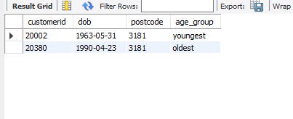

1. **In not more than 200 words, comment on whether the tables are in 3NF. Justify your argument with relevant examples, and then explain at least two ways to improve this database based on what you have learned in weeks 1-8. Draw specific examples from the database to support your answer.**

**Answer:**

**Checking 3NF for given tables:**

Lets check whether all tables are in 3NF or not *(We are assuming that all tables are already in 1NF and 2NF)*

**Calls Table:**

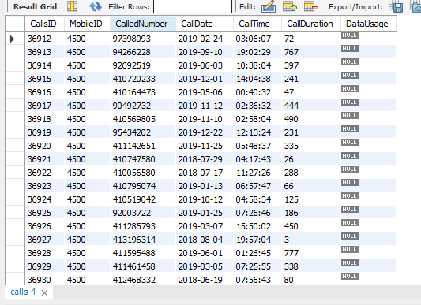

Calls table is in 3NF because no non prime attribute is dependent on anyother non prime attribute only “CallsID” (Primary Key) determine all other columns.

**Example:**

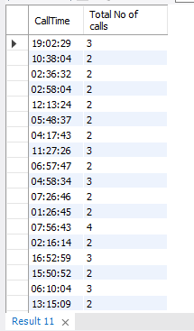

**MOBILE Table:**

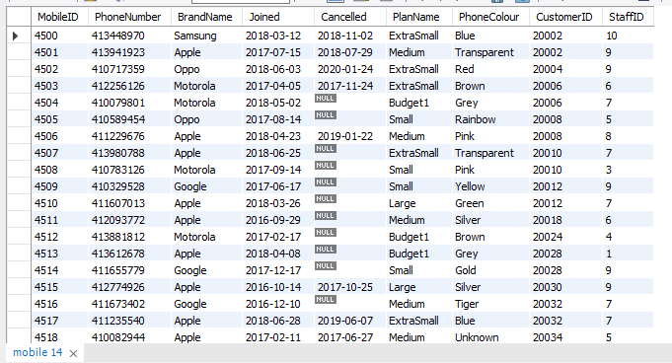

Mobile Table is also in 3NF because most closest column to have transitive property is phonenumber but even 1 phonenumber have more than 1 brandname.

**Example:**

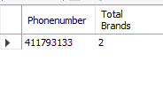

**Staff Table:**

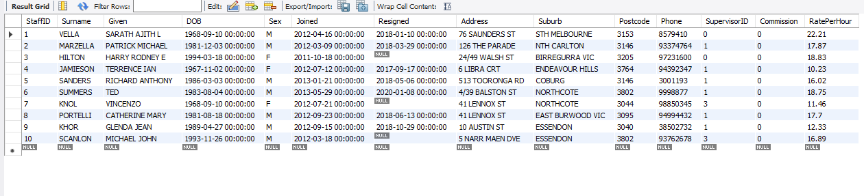

Staff Table is also in 3NF because this table has no transitive property.

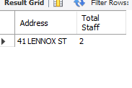

Even more than one staff member lives in same address

**Tower Table:**

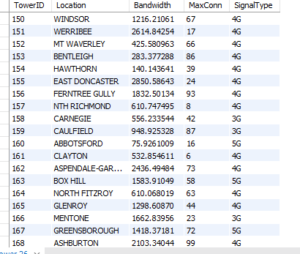

Tower Table is in 3NF because TowerID can be determined by Bandwidth but bandwidth can be a candidate key.

**Example:**

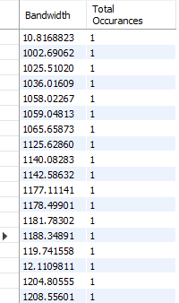

**Connect Table:**

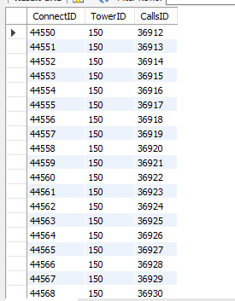

Connect table has no non prime attribute

**PlanName:**

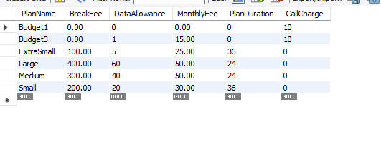

Plan also has no apparent non prime attribute.

**Customer Table:**

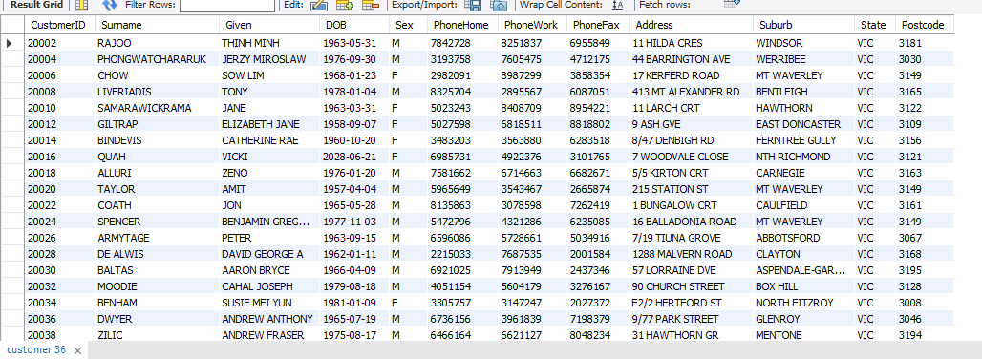

Customer table is also in 3NF because all attribute is only determined by CustomerID(Primary Key)

**Example:**

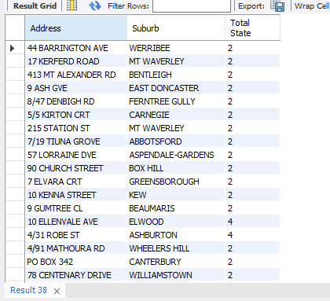

**Conclusion:**

Database is in 3NF.

**Improving Datasets:**

Database can be improved in 2 ways:

1. Create a new table that contain contact detail of customer with column customerID, PhoneHome,PhoneWork,PhoneFax.
2. Create a new table address of staff and add staffid,Address,Suburb,Postcode.